Computer Programming  
Lab Tasks



Department of Computer Science - BUIC

Name: Saad Ahmad

Enrollment Number: 01-134222-130

**Exercises/Lab Journal2**

1. Write a program in C++ that accepts the values of two variables num1 and num2 from the user and

1. Add them and store the result in a third variable sum.
2. Subtract them and store the result in a fourth variable difference.
3. Multiply them and store the result in a fifth variable product.

Display the output of this program in the following format:

Sum of ____________ and ____________ is _______________.

Difference of ____________ and ____________ is ____________.

Product of ____________ and ____________ is ______________.

These dashes will have the values of num1, num2, sum, difference and product respectively.

#include <iostream>

using namespace std;

int main()

{

int num1;

int num2;

int sum;

int difference;

int product;

cout << "Enter two numbers" << endl;

cin >> num1 >> num2;

sum = num1 + num2;

cout << "Sum of " << num1 << " and " << num2 << " is " << sum << endl;

difference = num1 - num2;

cout << "Difference of " << num1 << " and " << num2 << " is " << difference << endl;

product = num1 * num2;

cout << "Product " << num1 << " and " << num2 << " is " << product << endl;

return 0;

}

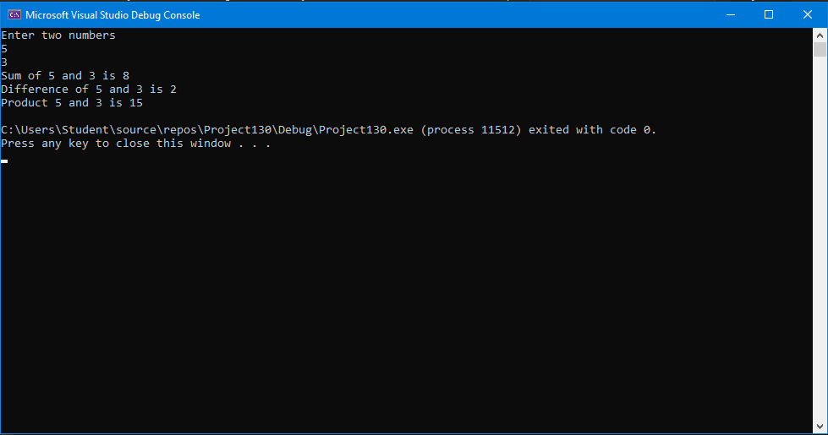

2. Write a program in C++ that accepts the base and height of a right-angle triangle from the user and displays the area of the triangle.

(Hint: Formula for area of right angle triangle = (base*height)/2)

#include <iostream>

using namespace std;

int main()

{

int base;

int height;

int area;

cout << "First enter the base then enter the height" << endl;

cin >> base >> height;

area = base*height / 2;

cout << "Area of the right angle triangle is : " << area << endl;

return 0;

}

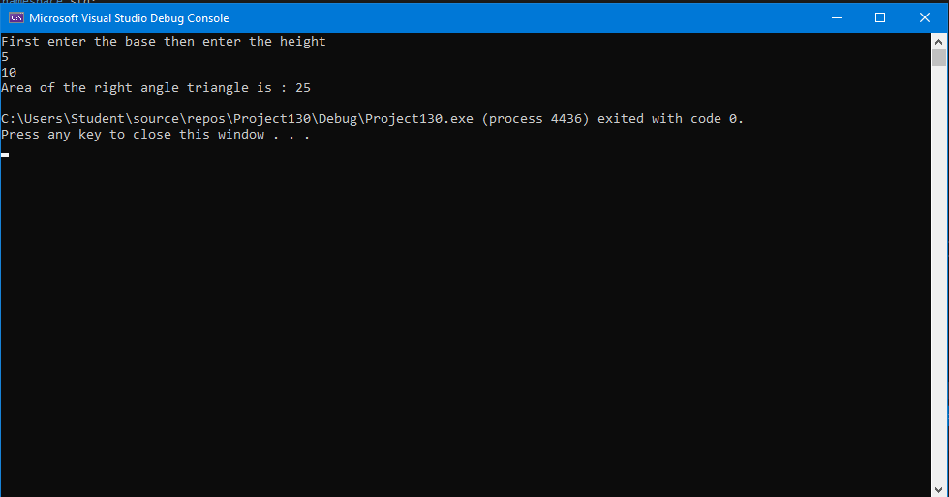

3. A person is running in a circular ground. Write a program in C++ that asks the user to input the radius of the ground in meters and the number of rounds the person completes. The program should display the total distance travelled by the person in meters.

**(Hint: Formula for distance = circumference*rounds)**

#include <iostream>

using namespace std;

int main()

{

int radius;

int rounds;

float distance;

cout << "First enter the radius then enter the number of rounds" << endl;

cin >> radius >> rounds;

distance = 2 * 3.14 * radius * rounds;

cout << "Total distance travelled is : " << distance << " meters " << endl;

return 0;

}

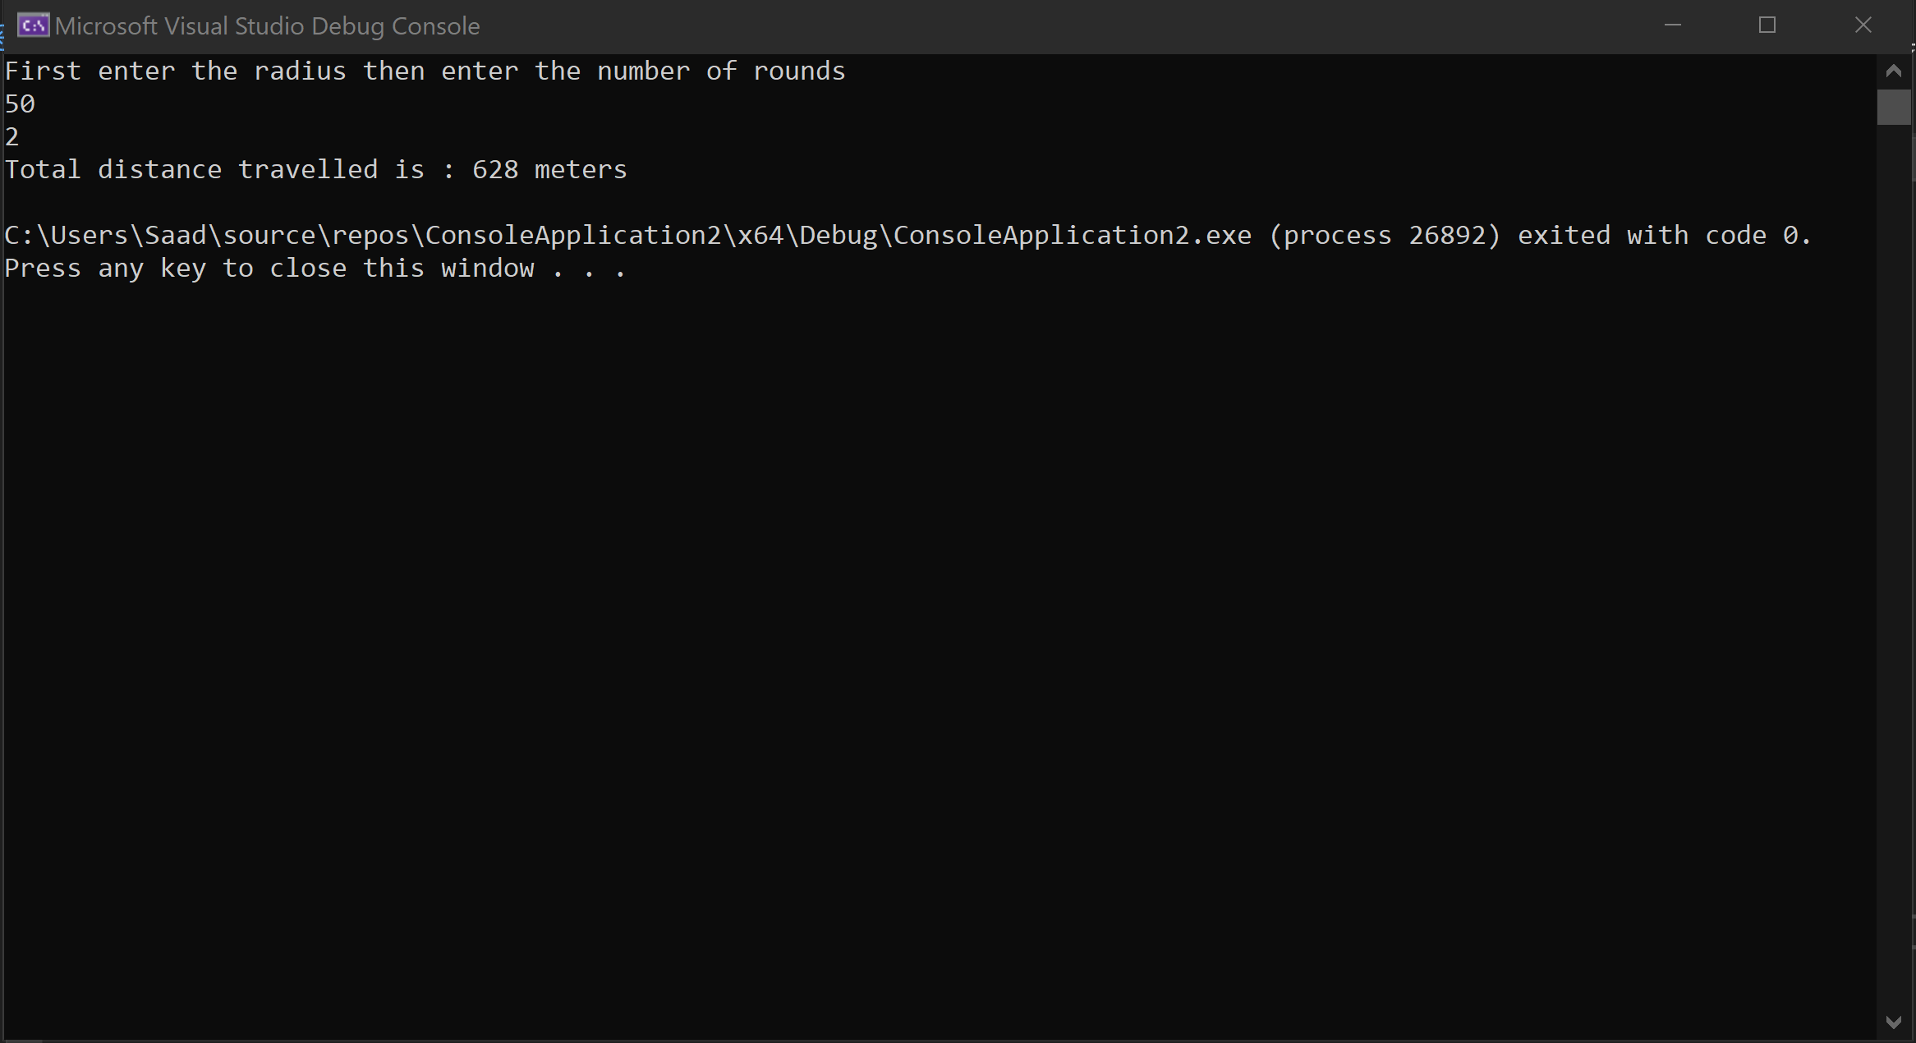

4. Write a program in C++ that asks the user to enter two integer numbers, stores them in variable 'num1' and 'num2' respectively. The program swaps the values of two variables with each other using a third variable 'temp' and displays the values of both variables after swap

#include <iostream>

using namespace std;

int main()

{

int num1;

int num2;

int temp;

cout << "Enter number 1" << endl;

cin >> num1;

cout << "Enter number 2" << endl;

cin >> num2;

temp = num1;

num1 = num2;

num2 = temp;

cout << "num1 = " << num1<< endl;

cout << "num2 = " << temp << endl;

return 0;

}

